Press Release
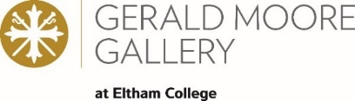
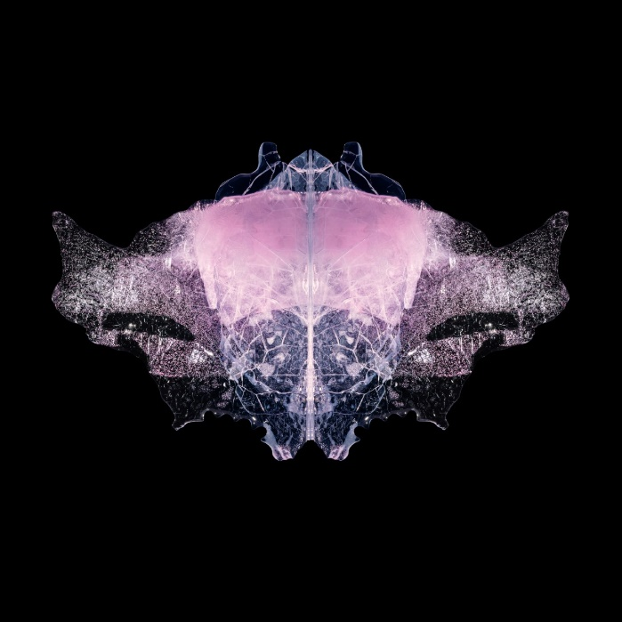
Shock of the Form

3 March – 19 March 2022
Private view: Thursday 3 March, 4pm-9pm

Open to public Saturday 10am-4pm or by appointment

Gerald Moore Gallery, Mottingham Ln, London, SE9 4RW

BUG_P1, Peer Lindgreen and Duncan Hamilton, 2017

Gerald Moore Gallery presents Shock of the Form, an exhibition of photography, film and ice sculptures bringing together two artists, photographer Peer Lindgreen and ice sculptor Duncan Hamilton.
The exhibition features 28 photographs by Lindgreen of Hamilton’s work with ice, alongside a giant crystal ice sculpture which takes centre stage in the gallery. Working collaboratively, the photos took Lindgreen and Hamilton over four years to produce, during which time they were testing the limits of ice with different processes.
Works such as BUG_P1, a 36-hour process uncovered unexpected and beautiful ways in which to manipulate this material. Flooded wedges of crystal ice with pink coloured water were allowed to fracture for the main body, whilst gasses bubbled in the ice to form delicate detailed frozen wings.
Playing around with different exposures to explore the relationship between light and ice is what fascinated Lindgreen, who captured these formations, sometimes operating in a minus-20c degrees shipping container in Hamilton’s south-west London studio. Works such as AURORA_ BLUE, made with blue water and cast with small crystal ice rocks, would be carefully lit to appear as planets in outer space and surrounded with flames from a gas torch to give off a blue haze.
‘Abstract other-worldly sci-fi pieces would greet me at times and other times more earthy works, a wonderful blend of ice sculpting and ice texture or both. We did a 360-degree slow motion short film of an alien form in icy rain, a frozen sea in misty conditions. Every time I went, I just fell more and more in love with this frozen art form. During this passage of time with ice, I can conclude I have now experienced a cold love poem with all its lovely imperfections.’ Peer Lindgreen
The focus of Hamilton’s professional life to date has been creating magical shapes from a block of ice. By contrast, this exhibition is an attempt to combine the study of form and sculpture with an exploration of the beauty of the ice itself.
‘It all started 45 years ago with the discarded bits from my ice sculptures. The wasted, unwanted bits. I became fascinated with the beauty contained within each unique piece of ice: bubbles, minerals and beautiful fractures which sometimes split the spectrum to produce mini rainbows of colour. It was like looking into another world. I wanted a record of the beauty of that world, and it's this ongoing conversation that Peer has captured with his camera.’ Duncan Hamilton
A film showing the practice of Hamilton’s work will be on display alongside traditional ice sculpting tools to introduce visitors to the methods of ice sculpting. There will also be live ice carving in our outdoor courtyard during the private view on 3 March.

NOTES TO EDITORS
About the artists:
Peer Lindgreen
‘The light and colours from my native northern European country, be it from the short winter days or the long evenings in the summer, has always influenced my way of photographing.’
Peer is a Danish photographer who, after studying photography, moved to London in 1992. His work has been shown in many group exhibitions and he has also had a solo exhibition at Denmark’s Photographic Museum. He has received numerous awards for his work, including Gold and Silver in The Association of Photographers Awards, and a D&AD pencil.

Duncan Hamilton
Duncan is a self-taught ice sculptor who started working freelance in 1975 when he was still a chef working in top restaurants in London. At that stage, Duncan who was the only professional ice sculptor in the UK, was working from Carlo Gatty’s Ice Factory in Battersea. Duncan’s major breakthrough came in 1977 when he made a large ice sculpture for the Hyde Park Hotel, (now the Mandarin Oriental) that was hosting a major awards event attended by Rolls Royce, Yves St Laurent and other major companies from all over Europe. The photograph of the ice sculpture that appeared in The Observer supplement was later picked up by the major news channels. This led to Duncan being commissioned to make sculptures for many celebrities, from Elton John to Justin Timberlake, London's grand hotels, product launches, advertising, film premieres, and music promos. www.icesculpture.co.uk
About Gerald Moore Gallery
Gerald Moore Gallery is a young centre for modern and contemporary art with learning at its heart. Opened in April 2012, the gallery is celebrating its 10-year anniversary in 2022. Uniquely set within the grounds of Eltham College, it is a valuable resource for the students and the local community. The gallery has gained momentum hosting some exciting exhibitions including works by Matisse, Louise Bourgeois and Rosemary Cronin, and supported emerging local artists. Gerald Moore Gallery was made possible with the foresight and generosity of Old Elthamian, Dr Gerald Moore, many of whose works are archived at the gallery and who has a permanent exhibition on display.
Geraldmooregallery.org
Instagram: @geraldmooregallery
Facebook: @geraldmooregallery
Twitter: @geraldmooregall

For more information, images and interview requests, or to attend the Private View
please contact: Stuart Haggas workofstuart@gmail.com
or info@geraldmooregallery.org

